Basic stats – 1 Assignment

Descriptive Analytics for Numerical Columns
Step 1: Load the Dataset - To load a dataset in Python, we typically use the pandas library. I had load a dataset from format using pd.read_csv().
df=pd.read_csv("sales_data_with_discounts.csv")

Step 2: Identify Numerical Columns - Once the dataset is loaded, we can identify numerical columns by selecting the columns with data types int or float. This can be done using the .select_dtypes() function.
df.select_dtypes(include=['number']).columns

Step 3: Calculate Mean, Median, Mode, and Standard Deviation- You can calculate the mean, median, mode, and standard deviation of the numerical columns as
df.select_dtypes(include=['number']).mean()
df.select_dtypes(include=['number']).median()
df.select_dtypes(include=['number']).mode().iloc[0]
df.select_dtypes(include=['number']).std()

Step 4: Brief Interpretation of the Statistics
Once you have the mean, median, mode, and standard deviation, you can interpret them:
- Mean: The average value of each numerical column.
- Median: The middle value when the data is sorted in ascending order. If the data is skewed, the median provides a better measure of central tendency than the mean.
- Mode: The value that appears most frequently in the dataset. This helps to identify any repeated patterns or the most common values.
- Standard Deviation: The spread or variability of the data. A higher standard deviation indicates that the values are more spread out, while a lower standard deviation indicates that they are closer to the mean.

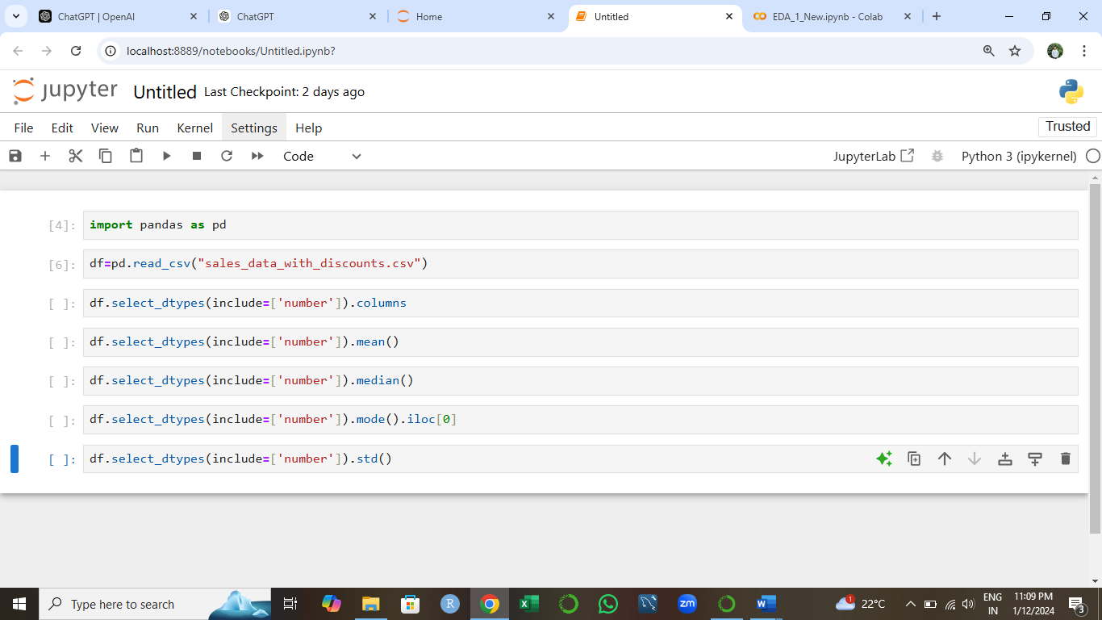

Data Visualization
- Histograms:
  - Plot histograms for each numerical column.
  - Analyze the distribution (e.g., skewness, presence of outliers) and provide inferences.

import matplotlib.pyplot as plt
df.hist()
plt.tight_layout()
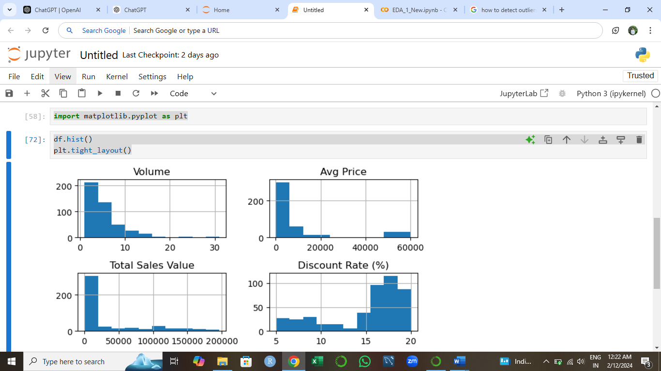
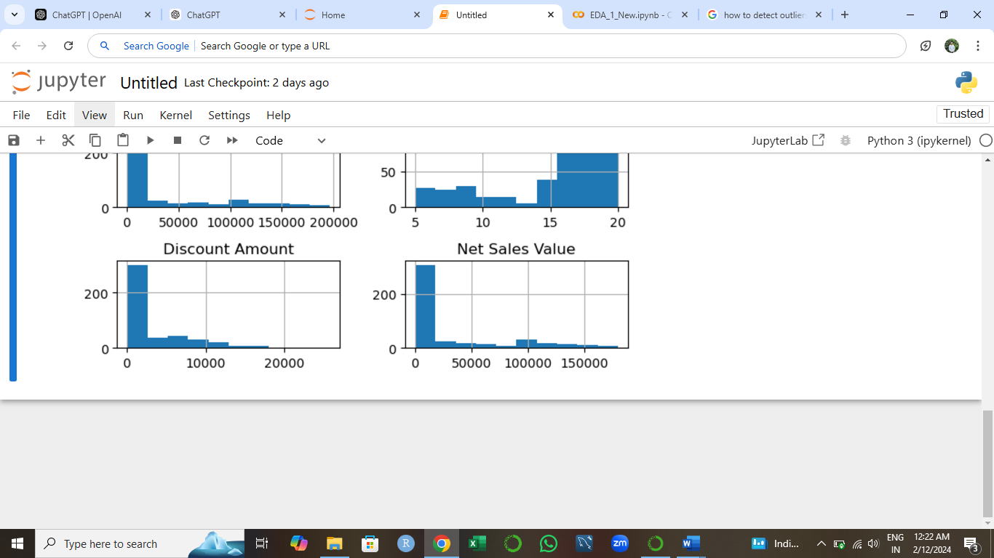

Volume:
- Distribution appears positively skewed, with most values concentrated at lower levels.
- Outliers exist at higher volumes.

Avg Price:
- A slight positive skew with the majority of prices centered around a specific range.
- Few instances of high average prices suggest potential outliers.
Total Sales Value:
- Positively skewed with a long tail extending towards higher values.
- Outliers likely at higher values
Discount Rate (%):
- Distribution appears moderately normal with a peak around a mid-range discount.
- Few extreme discount rates visible.
Discount Amount:
- Positively skewed, consistent with larger amounts tied to high-value transactions.
- Outliers likely at higher values
Net Sales Value:
- Positively skewed with a clustering of lower values.
- Outliers likely at higher net sales values.

- Boxplots:
  - Create boxplots for numerical variables to identify outliers and the interquartile range.
  - Discuss any findings, such as extreme values or unusual distributions.

  - import seaborn as sns
numerical_columns = ['Volume', 'Avg Price', 'Total Sales Value',
'Discount Rate (%)', 'Discount Amount', 'Net Sales Value']
plt.figure(figsize=(15,10))
for i, column in enumerate(numerical_columns, 1):
plt.subplot(2, 3, i)
sns.boxplot(df, y=column, color='skyblue')
plt.title(column)
plt.ylabel(column)
plt.xlabel('')
plt.tight_layout()
plt.show()
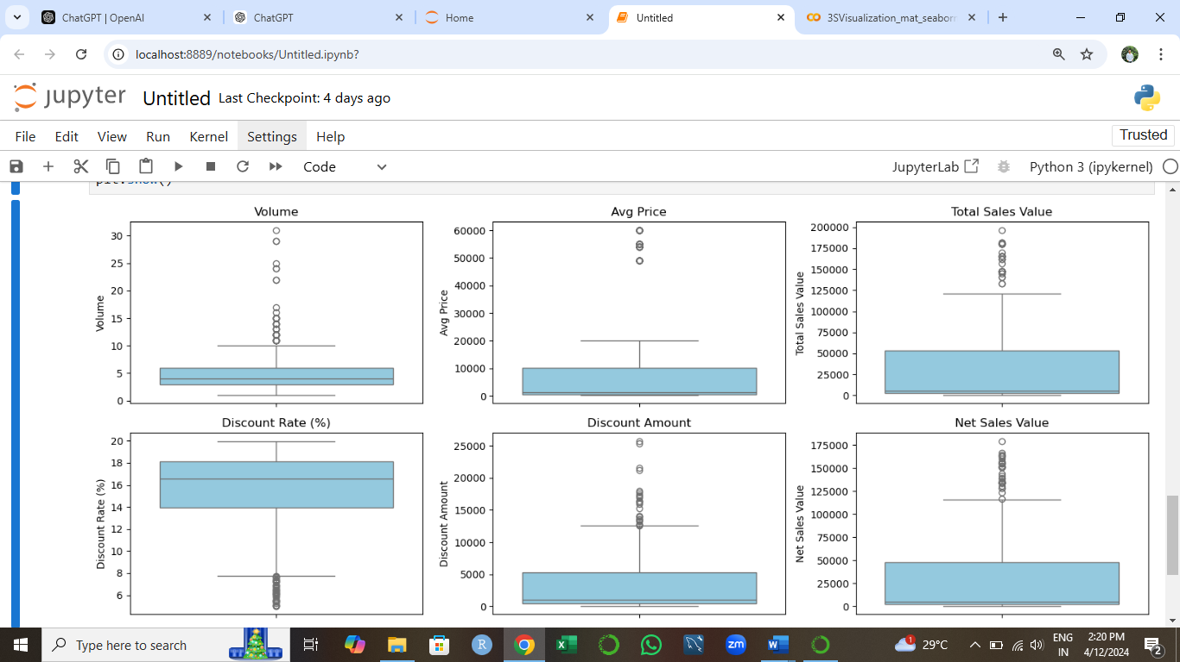
Volume:
- There are several outliers with unusually high sales volume compared to the median.
- The distribution is positively skewed, indicating a majority of lower-volume sales.
Avg Price:
- Outliers with significantly higher average prices are present.
- The interquartile range suggests a compact distribution for most values, but extreme high values create a long tail.
Total Sales Value:
- Outliers exist for significantly higher sales values.
- The spread suggests variability in sales performance.
Discount Rate (%):
- Discount rates have a few extreme values, but most fall within a narrow range.
- The majority of discounts are relatively small.
Discount Amount:
- Significant variability is observed, with some extreme high discounts indicating promotional activities.
- The distribution is right-skewed.
Net Sales Value:
- Outliers for exceptionally high net sales values are present.
- The core distribution shows more consistency compared to "Total Sales Value".

Bar Chart Analysis for Categorical Column:
  - Identify categorical columns in the dataset.
  - Create bar charts to visualize the frequency or count of each category.
  - Analyze the distribution of categories and provide insights.
- Identify categorical columns in the data
df.select_dtypes(include=['object']).columns
Index(['Date', 'Day', 'SKU', 'City', 'BU', 'Brand', 'Model'], dtype='object')

fig, axes = plt.subplots(nrows=4, ncols=2, figsize=(12, 16))
axes = axes.flatten()
for i, column in enumerate(categorical_columns):
sns.countplot(x=column, data=df, ax=axes[i])
axes[i].set_title(f'Frequency of {column}')
axes[i].tick_params(axis='x', rotation=45)
if len(categorical_columns) % 2 != 0:
fig.delaxes(axes[-1])
plt.tight_layout()
plt.show()

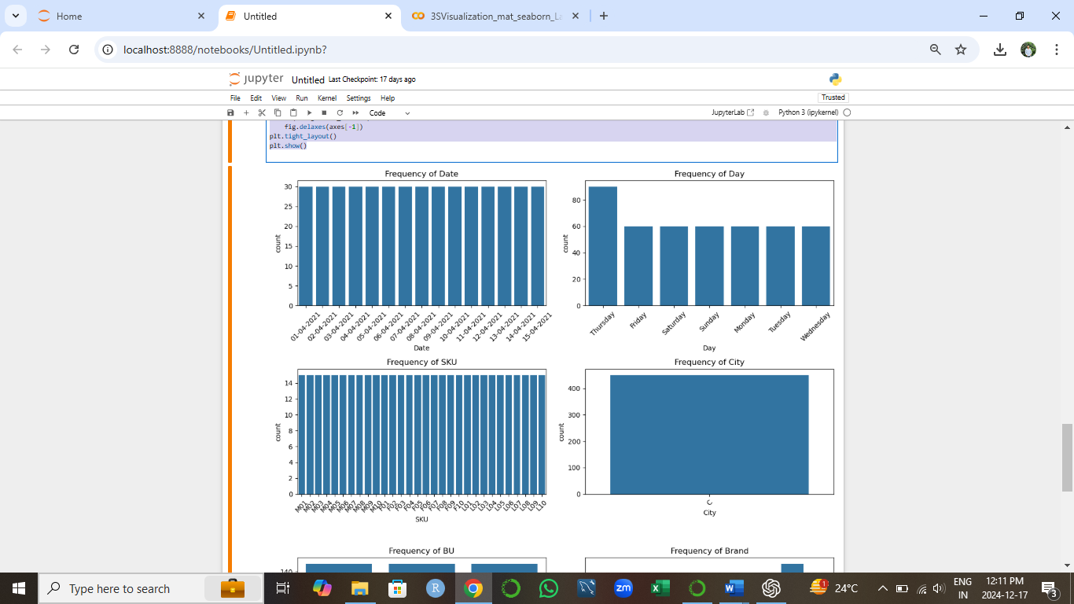
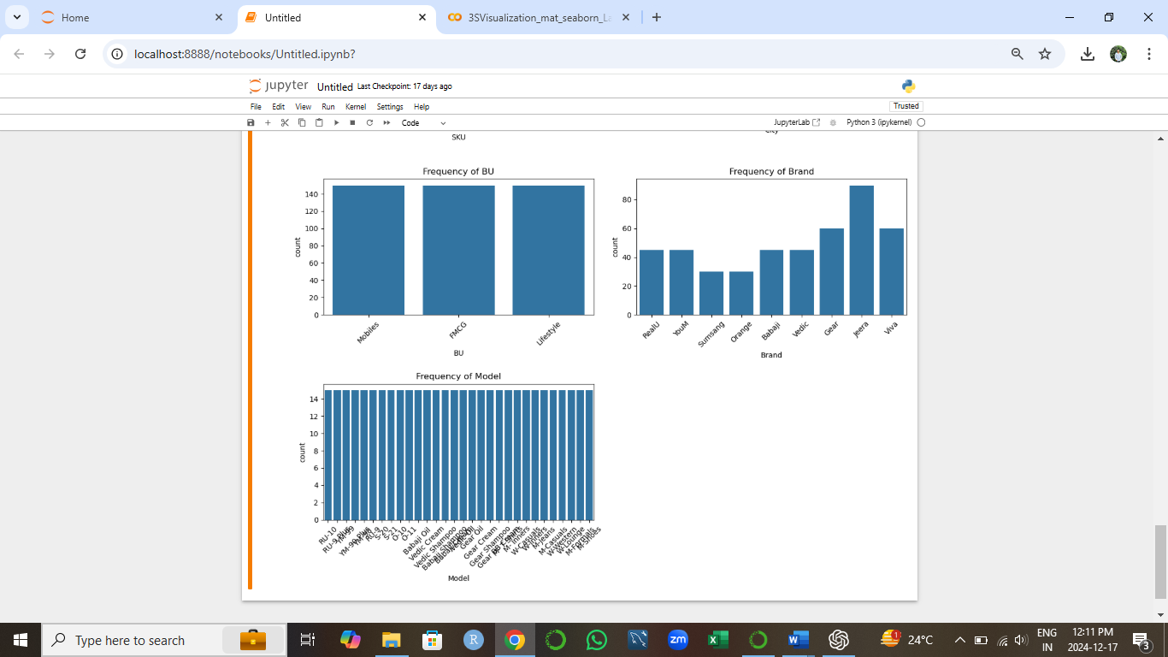
Frequency Of Date- All the dates are repeated for same number of times. So the count of date frequency are same.
Frequency Of Day- Thursday is repeated more than the others day. And other days having same frequency.
Frequency Of SKU- Frequency of all SKU are same. Count of all SKU are same.
Frequency Of City- Only one city in data set. So the frequency of city is same and common.
Frequency Of BU- Count of BU or Frequency is same. They are repeated for same number of time. The frequency of all brand is different.
Frequency Of Brand- The jeera brand is most selling. Number of jeera count is greater than other brands.
Frequency Of Model- Frequency of all model is same. They are repeated for same number of time.

Standardization of Numerical Variables
- Objective: To scale numerical variables for uniformity, improving the dataset’s suitability for analytical models.
- Steps:
  - Explain the concept of standardization (z-score normalization).
  - Standardize the numerical columns using the formula: z=x-mu/sigma

  - ​Show before and after comparisons of the data distributions.
Concept of Standardization (Z-Score Normalization)
Standardization, also called Z-Score Normalization, is a data preprocessing technique used to transform numerical data into a standard scale. This ensures that the data has:
- Mean (μ) of 0
- Standard Deviation (σ) of 1.
The formula for standardization is:
z=x−μ/σ
Where:
- x: Original data point
- μ: Mean of the column
- σ: Standard deviation of the column
- z: Standardized value
print("Before Standardization:")
print(df[numerical_columns].describe())
standardized_data = df[numerical_columns].apply(lambda x: (x - x.mean()) / x.std())
print("\nAfter Standardization:")
print(standardized_data.describe())

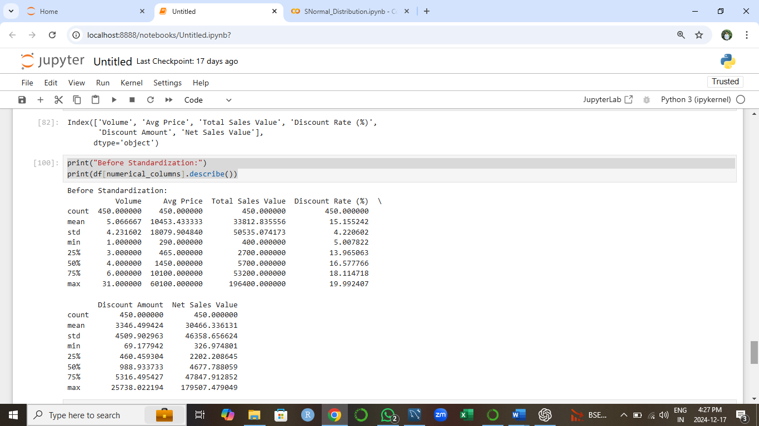

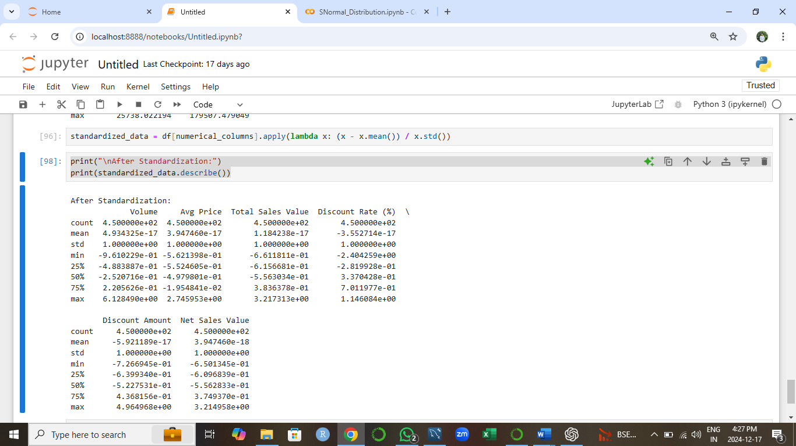

Conversion of Categorical Data into Dummy Variables
- Objective: To transform categorical variables into a format that can be provided to ML algorithms.
- Steps:
  - Discuss the need for converting categorical data into dummy variables (one-hot encoding).
  - Apply one-hot encoding to the categorical columns, creating binary (0 or 1) columns for each category.
  - Display a portion of the transformed dataset.
Why Convert Categorical Data into Dummy Variables (One-Hot Encoding)?
Categorical data often contains values that represent categories or groups. However, many machine learning algorithms and statistical models cannot directly process such non-numeric data. Converting categorical data into dummy variables (via one-hot encoding) ensures that these categories are represented numerically in a way that:
- Avoids Ordinal Misrepresentation: Assigning integers to categories may introduce unintended ordinal relationships that don't exist.
- Improves Model Compatibility: Algorithms like linear regression, logistic regression, and neural networks require numeric inputs.
- Preserves Information: Each category is represented as an independent binary column, ensuring no loss of information.

data_encoded=pd.get_dummies(df,columns=categorical_columns, drop_first=False,dtype=int)
data_encoded

